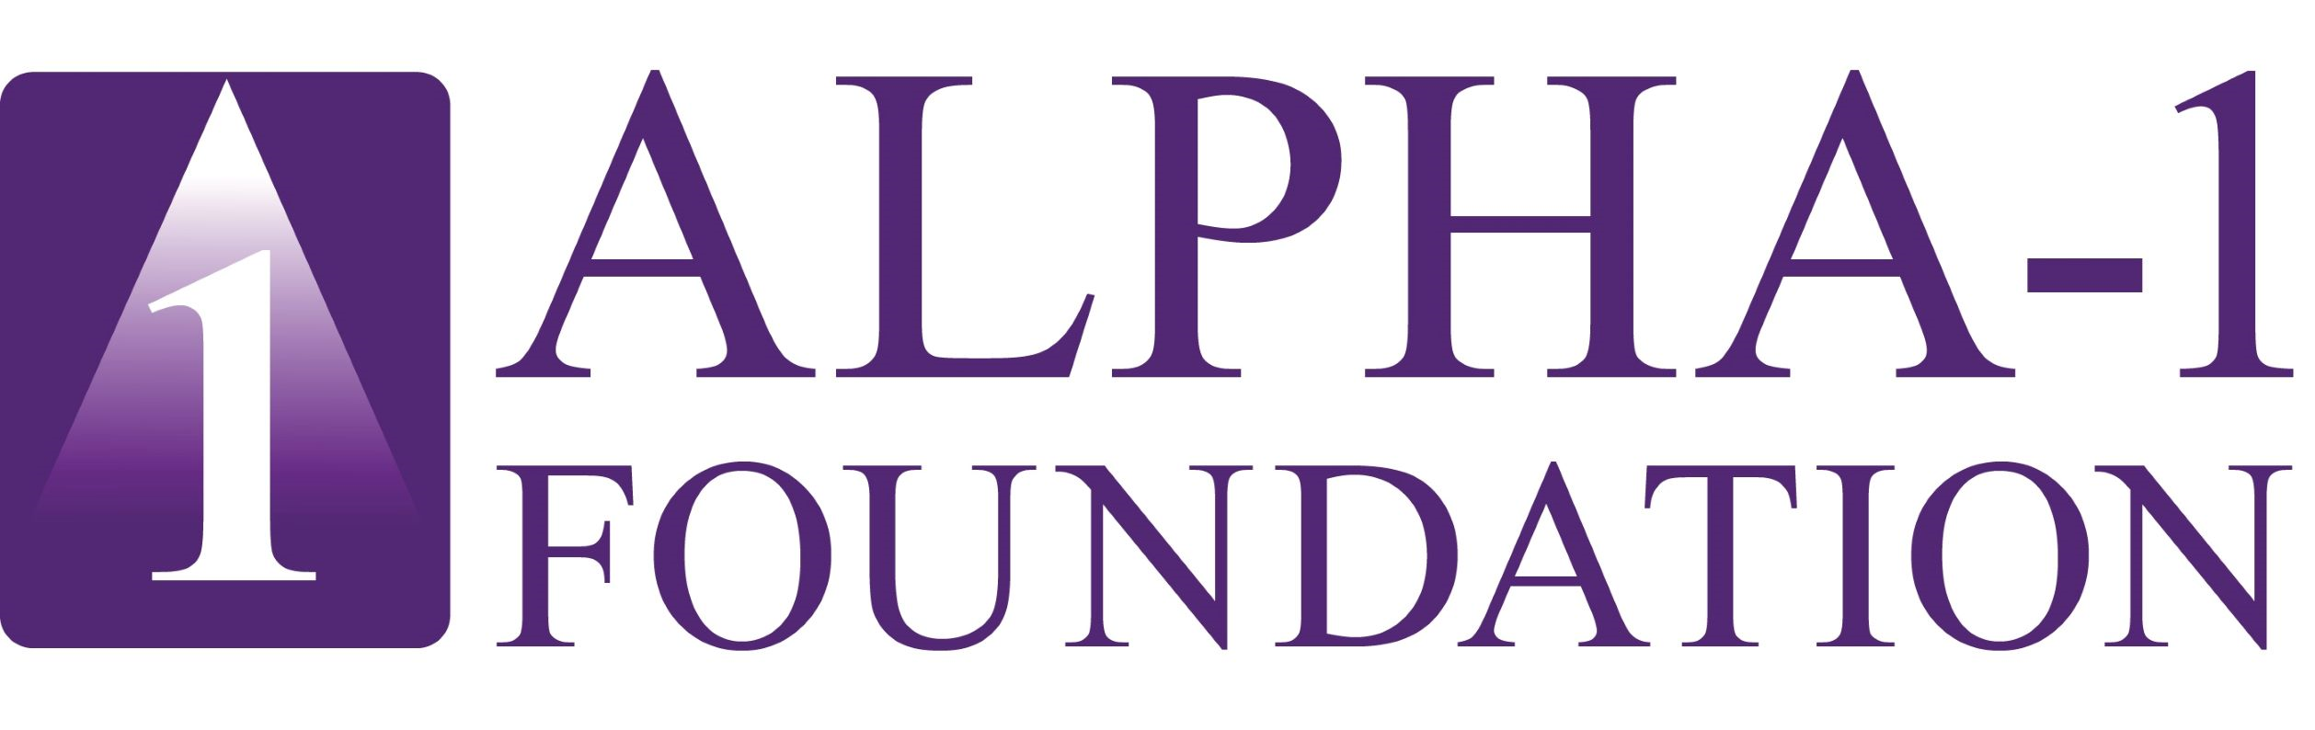

2025 Alpha-1 Global Patient Congress
Lisbon, Portugal
April 5, 2025

09:40am – 09:45am Welcome and Introduction Scott Santarella

09:45am – 09:55am Industry Sponsor Presentation CSL

09:55am – 10:10am Emerging Therapies in Alpha-1 Beam

10:10am – 10:30am Research Panel: Alpha-1 Registries & Jeanine D’Armiento, MD, PhD
Participating in Clinical Trials – EARCO, Marc Miravitlles, MD, FERS
Ireland and the Alpha-1 Foundation Gerry McElvaney, MD, BCh, BAO,
FRCPI, FRCPC
10:30am – 10:40am Q & A

10:40am – 11:10am The Augmentation Therapy Journey Sylvain Grenier, PharmD
in Canada and the Nordic Alliance Angela Diano
Knut Skaar
11:10am – 11:20am Q & A

11:20am – 11:40am Break

11:40am – 11:50am Industry Sponsor Presentation Grifols

11:50am – 12:05pm Emerging Therapies in Alpha-1 Kamada

12:05pm – 12:25pm Progress Updates from South America Mariano Fernandez Acquier, MD

12:25pm – 12:35pm Q & A

12:35pm – 12:45pm Industry Sponsor Presentation Takeda

12:45pm – 01:45pm Lunch

01:45pm – 02:00pm Emerging Therapies in Alpha-1 Sanofi

02:00pm – 02:20pm Alpha-1 Europe Alliance – Working Collectively Fernanda Aspilche
On Behalf of Patients Cristina Barbiero

02:20pm – 02:30pm Q & A

02:30pm – 02:50pm Patient Empowerment – Your Voice in Advocacy Kinga Wojtowicz
& Policy Ines Aoufi

02:50pm – 03:00pm Q & A

03:00pm – 03:30pm Research Panel – Advancements in AATD Q & A Andrew Wilson, MD
Mark Brantly, MD
Gerry McElvaney, MD
Robert Sandhaus, MD, PhD
Alice Turner, MBChB, PhD
Jeff Teckman, MD
Pavel Strnad, MD
Jeanine D’Armiento, MD, PhD

03:30pm – 03:45pm Emerging Therapies in Alpha-1 Takeda

03:45pm – 04:05pm Break

04:05pm – 04:35pm Panel: Living with Alpha-1 - Patients’ Perspective Elena Goyanes
Shane Fitch
Carlos Cambon
Peg Iverson
Frank Willersinn
Steve Knowles
Jennifer MacDonald
Anabela Lemos

04:35pm – 04:45pm Q & A

04:45pm – 05:00pm Emerging Therapies in Alpha-1 Wave

05:00pm – 05:15pm Alpha-1 Foundation Global Program Update Scott Santarella
05:15pm – 05:25pm Q & A

05:25pm Closing Remarks Scott Santarella

